👉 UnicornXMedia = Founder Visibility Platform
You are:
👉 “We get founders & Investors featured, seen, and positioned through media + events.”
🏠 1. HOMEPAGE Ideas
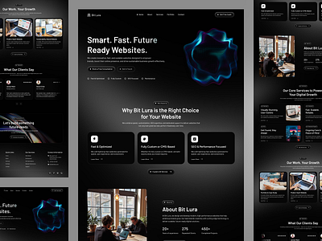

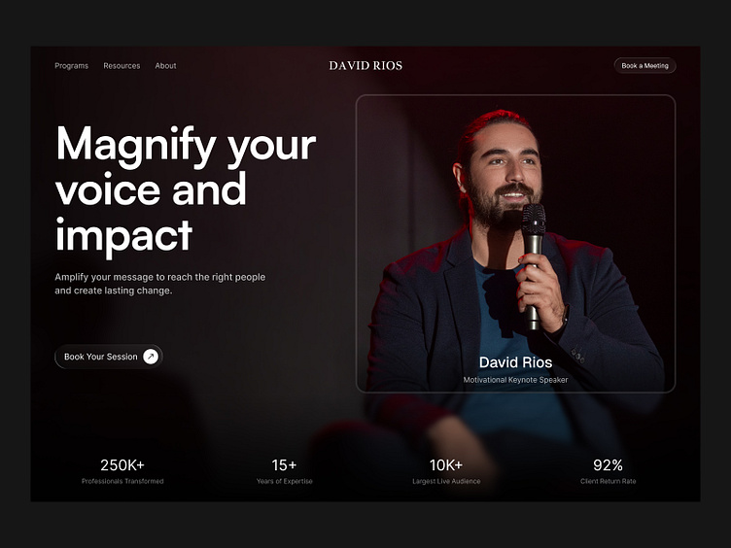

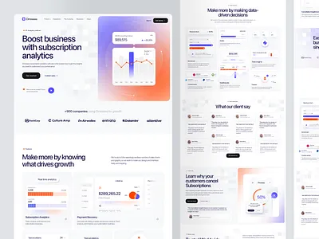

🔥 HERO SECTION
Headline:
Become Impossible to Ignore
Subtext:
We help founders get featured across media, events, and high-visibility platforms.
CTA Buttons:
- Explore Opportunities
- Get Featured

🚀 ACTIVE OPPORTUNITIES (Dynamic)
Cards:
- Pinkvilla (LIVE)
- PR Features
- Podcast Features
Each card includes:
- Title
- Reach (e.g. 5B+)
- Deadline
- CTA → Apply

📊 PROOF
- 5B+ Reach
- 100+ Celebrities
- 500+ Media Placements

🧠 HOW IT WORKS
- Choose an opportunity
- Apply
- Get featured

📰 BLOG PREVIEW (AUTO CMS)

🔚 CTA
“Apply for Visibility”

🎯 2. OPPORTUNITIES PAGE (CORE MONEY PAGE)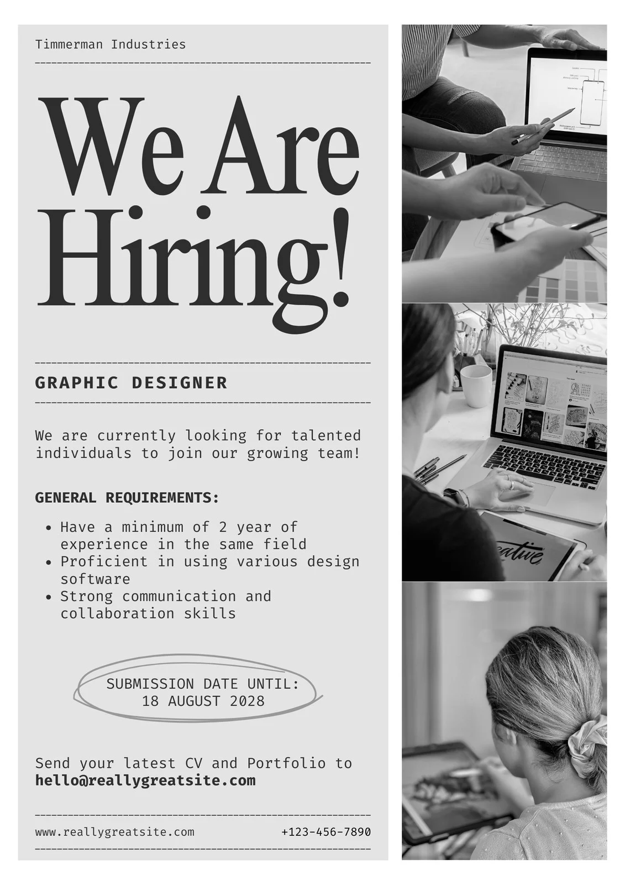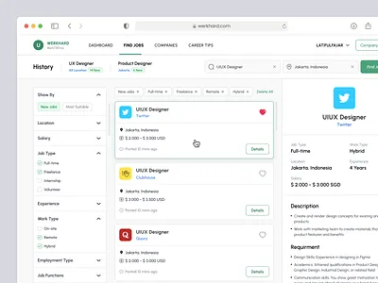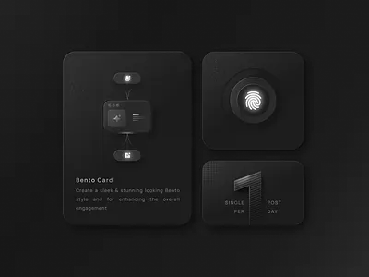

FILTERS:
- All
- PR
- Events
- Podcasts

CARD STRUCTURE:
- Title (Pinkvilla Screen & Style Icons)
- Type (Event / PR)
- Reach (5B+)
- Deadline
- CTA → View Details

🎤 3. OPPORTUNITY DETAIL PAGE (TEMPLATE)
👉 This is where your Pinkvilla content goes.

🔥 HERO
Pinkvilla Screen & Style Icons 2026
Edition 5

📊 PROOF (REAL DATA ONLY)
From your deck:
- 5B+ Organic Reach
- 29M+ Interactions
- 100+ Celebrities
- 50+ Brands
(From past editions)

🎯 WHAT YOU GET
- Media visibility via Pinkvilla
- Featured video coverage
- PR amplification
- Authority positioning
- Networking with founders & brands

📡 DISTRIBUTION
- Pinkvilla Instagram + YouTube
- OTT + TV integrations
- News + Radio coverage
- OOH campaigns (Mumbai + Delhi)
- Pre + post digital campaigns

🎬 EVENT DETAILS
- Venue: JW Marriott, Juhu
- Audience: Curated founders, brands, industry leaders

🖼️ GALLERY (FROM YOUR PDF)
Use:
- Celebrities
- Stage shots
- OOH
- Social coverage

🚨 CTA
- Apply as Founder
- Apply for Feature

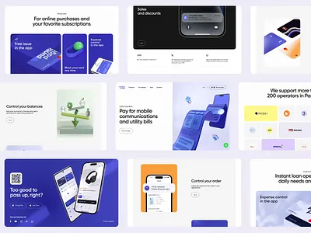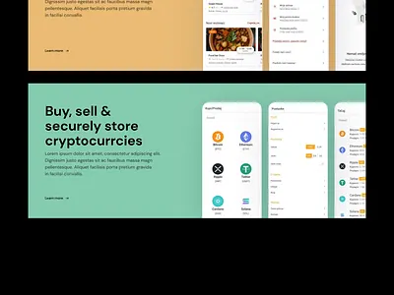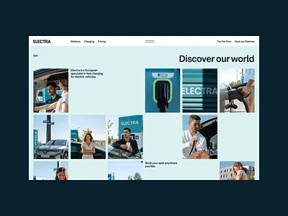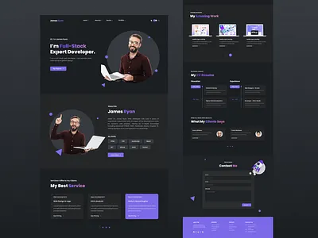
LOGIC:
When:
👉 deadline ends
Then:
👉 move to archive

SHOW:
- Pinkvilla (after event)
- Past PR campaigns
- Results (if available)

📢 5. PR SERVICES PAGE
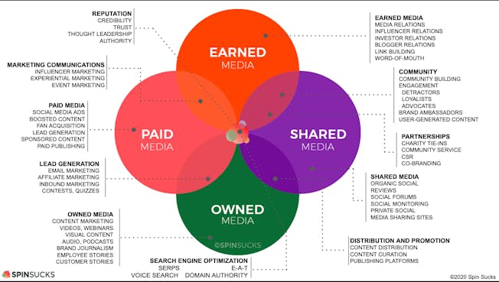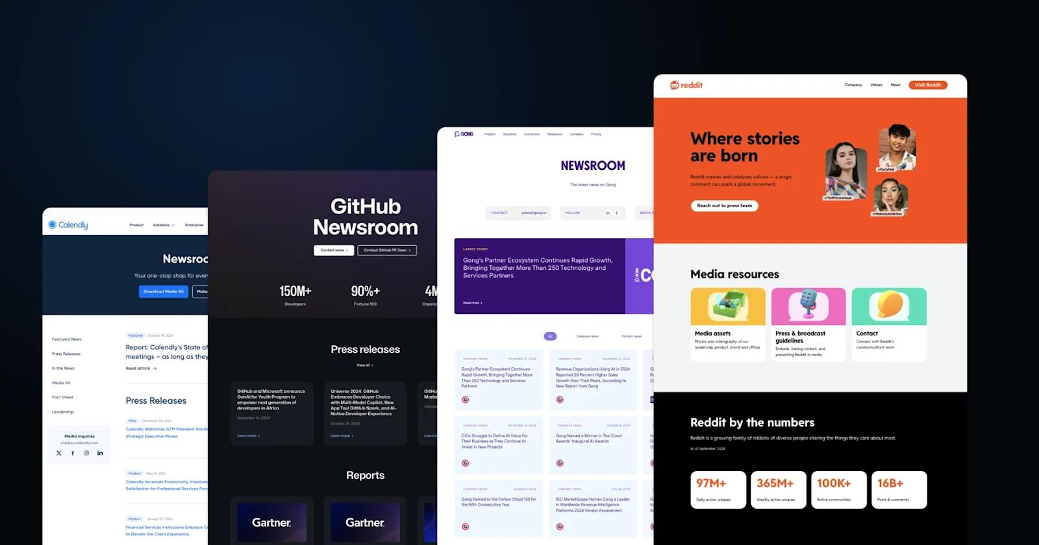

HEADLINE:
Get Featured Across 500+ Media Platforms

PROCESS:
- Apply
- Story Creation
- Distribution

CTA:
Apply for PR

📰 6. BLOG (CMS)
- Admin panel
- Add blog
- SEO fields
- Auto homepage display

📞 7. APPLY FORM (CRITICAL)

FORM FIELDS:
- Name
- Company
- Stage (idea / revenue / scale)
- Budget (important)
- Goal

⚙️ BACKEND LOGIC (VERY IMPORTANT)

DATABASE: Opportunities
- id
- title
- type
- description
- reach
- deadline
- status:
  - active
  - archived

AUTOMATION:
IF:
👉 current date > deadline
THEN:
👉 move to archive

CMS CONTROL:
You can:
- Add opportunity
- Edit
- Archive

💣 FINAL REALITY CHECK
This version:
✅ makes you look premium
✅ focuses on visibility (your real strength)
✅ scalable (future opportunities)
✅ not dependent on one event

